
ОБЩЕСТВО С ОГРАНИЧЕННОЙ ОТВЕТСТВЕННОСТЬЮ
«ЛАЗЕРТАГ»

ПАСПОРТ

Смоленск
LIMITED LIABITY COMPANY
LASERWAR

SPECIFICATION

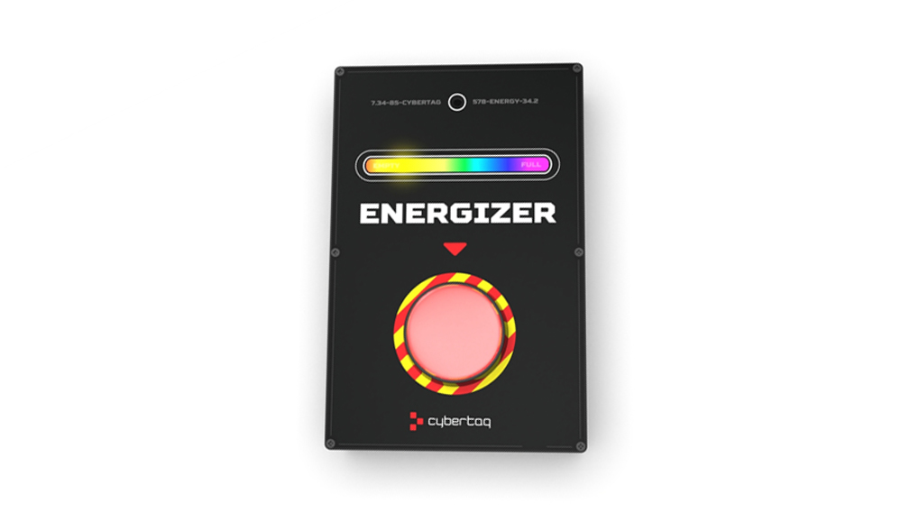

Play Set
ENERGIZER

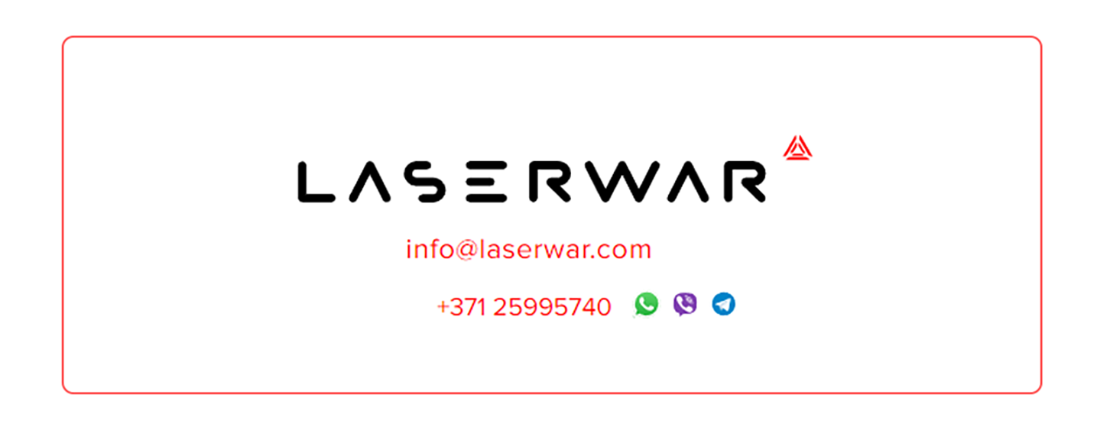
Dear Customer!
Thank you for choosing our products! LLC LASERWAR would like to assure you that you will enjoy the purchased device and it will serve you long.
This guarantee period is 12 months from the purchase day provided that the terms and conditions set out in this guarantee are complied with.

2
11
- Purpose
The Energizer gaming set is an additional device designed for playing laser tag game.

- Technical Specifications
Weight | 0,895 kg
Sizes | 250 х 145 х 55 mm
Battery type | SLA;  12 V; 1200 mAh
Battery life | Up to 10 hours

- Delivery Set

№ | Name | Unit of measurement | Quantity
1. | Energizer | pc. | 1
2. | Product specification | pc. | 1

- Contact details
Official website:
www.laserwar.com

e-mail:
info@laserwar.com
help@laserwar.com Date of purchase:____________

skype:
info@laserwar.com
help@laserwar.com
INCLUDEPICTURE "https://psv4.userapi.com/s/v1/d2/Jt0QPvHZOnLhvRdB9_1GDxDXz-xftQEsJhKZN7UlcC57k9YFKiXSRqouPulInl7jrF9Q41HqZTBMSAXGGURRqVDShvDuUOmMDEZtIQRXSpoBNJzKdDA4Em6thDuLG8-S-E8TMLo1i6Af/latviyskaya_pechat1.png" \* MERGEFORMATINET INCLUDEPICTURE "https://psv4.userapi.com/s/v1/d2/Jt0QPvHZOnLhvRdB9_1GDxDXz-xftQEsJhKZN7UlcC57k9YFKiXSRqouPulInl7jrF9Q41HqZTBMSAXGGURRqVDShvDuUOmMDEZtIQRXSpoBNJzKdDA4Em6thDuLG8-S-E8TMLo1i6Af/latviyskaya_pechat1.png" \* MERGEFORMATINET 

______________________
signature

Serial number

3
10
- Description and operation
  - Construction
The Energizer gaming set is made in a black metal case.
The main body is a construct in which the power supply, control units, and module fastening elements are installed. On the case there is an activation button, an RGB LED, and a sticker made of polyester film.
The Energizer gaming set is designed to fully restore the health and ammunition of “killed” players.

  - Changing the tactical and technical characteristics of a gaming set

The Energizer gaming set is configured using the MILSIM configurator.

Information about repair works during the guarantee period (filled out by the service centre)

Date:__________________  Maintenance carried out: _____________________________________________________________________  Service centre stamp | Date:__________________  Maintenance carried out: _____________________________________________________________________  Service centre stamp
Date:__________________  Maintenance carried out: _____________________________________________________________________  Service centre stamp | Date:__________________  Maintenance carried out: _____________________________________________________________________  Service centre stamp
Date:__________________  Maintenance carried out: _____________________________________________________________________  Service centre stamp | Date:__________________  Maintenance carried out: _____________________________________________________________________  Service centre stamp

4
9
To enter the device into programming mode, connect the USB base to the computer and launch the MILSIM configurator. Position the Energizer in such a way that the base sensors are in the direct line of sight of the first aid kit scale at a distance of no more than 1 meter. Turn it on or, if the first aid kit is already turned on, apply the “New Game” command to it from the remote control. When connected correctly, the RGB LED will light up purple and a beep will sound three times. Having set the necessary parameters, click the “Record” button.
  - Preparing for work
The Energizer gaming set is turned on using a button located on the left side of the case. The choice of game mode and the number of sets used are adjusted by briefly pressing the activation button. Confirmation of the choice and use of the first aid kit is carried out by pressing the activation button.

Guarantee terms and conditions:
1. The guarantee comes into force upon presenting of this slip, with a confirmed by a repair center date of purchase displayed.
2. These guarantee promises cover only the devices purchased from an official representative of LLC LASERWAR, or its official dealer.
3. This guarantee does not cover products in the following cases:
- if the customer does not follow the directions outlined in the User’s manual;
- in case of damage;
- if any objects or liquids get inside of the device.;
- if it gets damaged by pets;
- unauthorized access to the units and details of the device;
- abuse or misuse, including failure to use this product for its normal purposes;
- any cause beyond the control of the company, Force Majeure (natural catastrophes, fire, accidents, etc.);
- if the device fails due to incorrect connection, voltage fluctuations, and/or improper care.
4. Should it happen that you loose your guarantee slip, you will not be issued a copy.

5
8
6
7
- Rules of operation
1. Weather conditions. We strongly do not recommend using the equipment in rain or at temperatures below -20°C..
Avoid getting moisture inside the model. If this happens, stop using it and dry the equipment at room temperature for at least 2 hours.
Under no circumstances should you immediately recharge equipment that has been used at low temperatures. It is necessary to allow the electronics to warm up and dry the condensation that occurs during sudden changes in weather conditions.
2. Batteries. The “Smart First Aid Kit 2.0” gaming kit uses sealed lead-acid batteries as a power source. To recharge them, you must use only the Sonar charger.
First of all, you need to connect the charger to the gadget, and then to plug it into the socket.
The charging process can be monitored using a special indicator. If the battery is low, the LED lights up red; at the end of the charging process, the color changes to green.
Attention! Guns must be recharged immediately after use and under constant supervision at an ambient temperature of at least 0°C for no more than 2 hours.
3. Headband. While using headband, you should pay attention to the need to use special hygienic cuffs that protect electronic components from moisture. If the headband gets wet during use, this can lead to failure of the electronics - the band must be dried immediately.

In addition, when using the headband, you may face mechanical damage to the caps protecting the sensors. In such cases, the caps must be replaced. The headbands must be recharged immediately after playing for no more than 80 minutes.
The equipment must be stored in a well-ventilated area at a temperature from +18°C to +30°C and relative humidity from 45 to 65%.
Store the equipment only in a charged state (ideal at the rated battery voltage).

- Warranty
The manufacturer guarantees the reliability of operation of the individual LASERWAR kit if the user complies with the operating conditions. The manufacturer undertakes to replace or repair an individual set of equipment free of charge on condition that the consumer will comply with transportation rules, storage, operation and payment for delivery of faulty equipment to the service center.
The warranty for batteries, speakers, and IR modules is 14 DAYS.
ATTENTION! In case of improper use of batteries (charging with the wrong type of charger), the warranty does not apply to the batteries!

You can find the full technical manual for operating laser tag equipment from the LASERWAR company on our website www.laserwar.ru.

